# Freight Dispatch Course Guide – TRUCKING TRANSPORTATION ACADEMY LLC

|  |
| --- |
| Course Guide |

# Launch Your Successful Freight Dispatch Career with Trucking Transportation Academy



The Freight Dispatch industry is the backbone of modern commerce, responsible for the seamless movement of goods across the world. To succeed in this field, you need a deep understanding of transportation logistics, cutting-edge technology, and the ability to make critical decisions under pressure.

At Trucking Transportation Academy, we’re equipping aspiring newcomers with the skills they need to succeed in the industry. With our Fright Dispatcher course serving as the launch pad for a rewarding career, we’re opening the doors to this traditionally male-dominated field wide open to everyone.

Begin an exciting journey that will unlock the secrets of efficient transportation and connect you with the heartbeat of the global economy. Join us at Trucking Transportation Academy and prepare yourself for a high-performance career with financial rewards to match.

### CTA: Get Started

## Trucking Transportation Academy

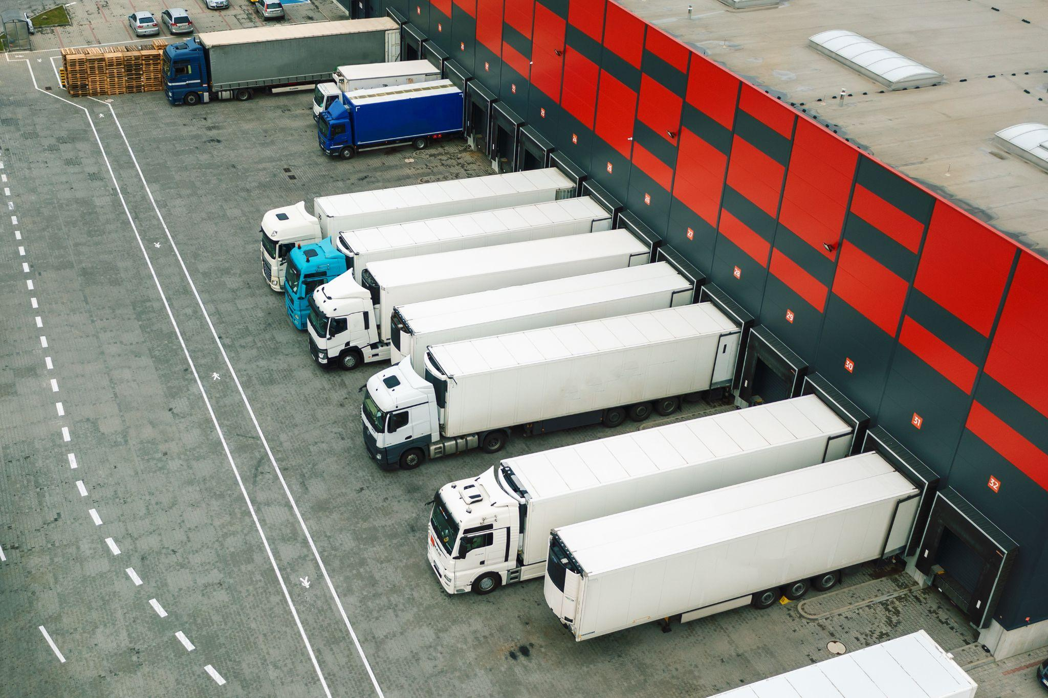

Trucking Transportation Academy is transforming the field of freight brokerage and dispatch, offering women the opportunity to thrive. The company’s founder, Kecia Terrelonge, has drawn on her own success in the industry to offer a course that helps individuals, regardless of gender, succeed.

The course provides comprehensive training that covers consulting, business setup, compliance, safety, federal filings, and much more. With Terrelonge encouraging women to explore the potential of the transportation industry, the Academy equips students with the knowledge and skills needed to establish prosperous trucking transportation careers and businesses for themselves.

## About the Course



Our comprehensive training program is designed to equip you with all the knowledge and skills you need to become a successful Freight Dispatcher. In the training, you'll explore the intricacies of freight dispatch, covering such topics as route optimization, load planning, real-time tracking, compliance, and communication.

You'll learn how to efficiently manage shipments, minimize costs, and maximize profitability for your organization and clients. Whether you're looking to launch a rewarding career, improve your current job prospects, or enhance your business operations, our Fright Dispatch Training program provides you with all the resources you need.

## Our Course Structure



Our Freight Dispatch course consists of 9 modules that cover every aspect of the industry in detail. Whether you’re an aspiring newcomer or a veteran looking for improved performance, we have the key to your future success.

|  |  |
| --- | --- |
|  | **MODULE 1: Business Setup** In the first module, we guide you through the steps of setting up your dispatch business, teaching you how to establish a solid foundation for your success. |
| **MODULE 2: What is the Role of a Dispatcher?** Explore the responsibilities of a dispatcher, from coordinating shipments to ensuring timely deliveries. | {<a href="https://www.vecteezy.com/free-photos/freight-dispatcher">Freight Dispatcher Stock photos by Vecteezy</a>} |
|  | **MODULE 3: What is the Role of a Broker?** Learn about freight brokerage and understand how brokers connect shippers and carriers. |
| **MODULE 4: What is the Difference Between a Dispatcher and a Broker?** With brokers connecting shippers with carriers and dispatchers working for the carrier, you’ll learn the strengths and responsibilities of each role. |  |
|  | **MODULE 5: What is a Shipper?** Explore the shipper's perspective and needs and learn how to meet their shipping requirements efficiently. |
| **MODULE 6: What is an Owner Operator/Carrier?** Understand the critical role played by owner-operators and carriers in the logistics process. |  |
|  | **MODULE 7: How Do I Find Freight?** Master the art of finding and securing valuable freight opportunities for your clients. |
| **MODULE 8: How Much Money Can I Make?** Gain insights into the outstanding financial rewards of a career in freight dispatch. |  |
|  | **MODULE 9: Forms** Access essential forms and documents that simplify your daily operations as a Freight Dispatcher. |

## Course Key Features

* **In-Depth Curriculum**

Our course offers a comprehensive curriculum that covers every aspect of Freight Dispatch, from business setup to advanced strategies.

* **Expert Instructors**

Learn from seasoned professionals with extensive experience in freight management, and benefit from their insights and industry knowledge.

* **Hands-On Practical Training**

We emphasize practical training to ensure you're well-prepared for real-world scenarios and provide hands-on experience in dispatching and brokerage.

* **Job Opportunities**

Our training program opens doors to exciting career opportunities in the logistics industry, taking full advantage of the high demand for skilled Freight Dispatchers.

## Benefit from Advanced Skills & Resources



Our Freight Dispatch Course doesn’t just teach you the basics, it transforms you into an expert ready to thrive in the industry.

|  |  |
| --- | --- |
| {Image} **Advanced Skills** Master the specialist dispatching and brokerage skills needed to stay ahead in the competitive world of freight management. | {Image} **Essential Forms** Get access to the forms and documents that play a crucial role in your day-to-day operations as a Freight Dispatcher. |

## Our Freight Dispatch Course is the Perfect Choice For You if…

* You are an aspiring Freight Dispatcher looking to kickstart a logistics career.
* A Logistics Entrepreneur planning to start or expand your business.
* A Carrier Owner and Operator aiming to optimize your operations.
* A Supply Chain professional searching for efficiency improvements.

Join us today and begin a rewarding journey in the world of Freight Dispatch. With Trucking Transportation Academy with you every step of the way, we’ll unlock a world of opportunities for you in logistics and transportation.

## Explore New Business Horizons With Kecia Terrelonge

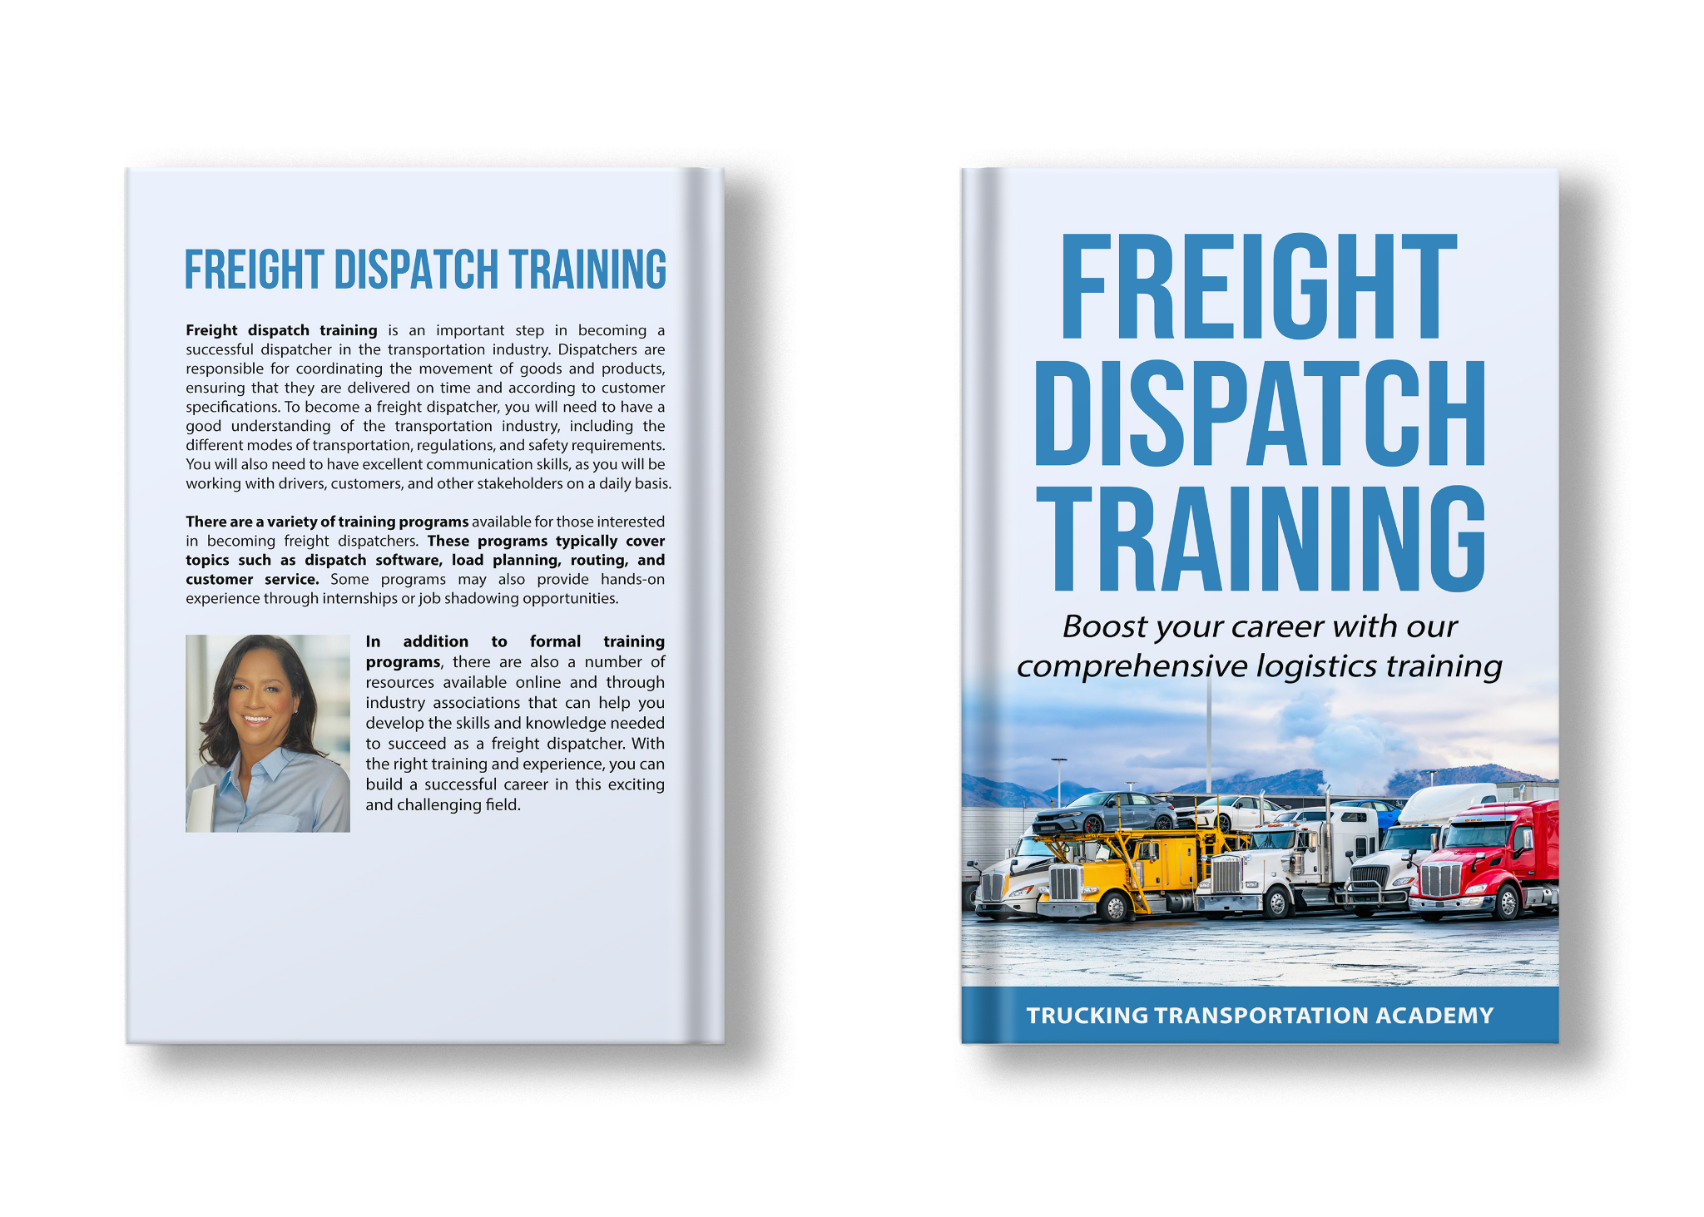

In a sector historically dominated by men, Kecia Terrelonge, is changing the face of the freight brokerage and dispatch industry. As the founder of Trucking Transportation Academy, she is intent on breaking down barriers and inspiring women to enter the field. Drawing on her highly successful career in trucking transportation, Terrelonge launched the academy to provide candidates with everything they need to know to launch their own successful trucking businesses.

While the academy is open to everyone, Terrelonge is particularly passionate about encouraging women to explore opportunities within the industry. With more than 300,000 female truckers already making their mark in the U.S., Terrelonge is opening the doors to a more inclusive and diverse future in this lucrative arena.

To find out more about Kecia Terrelonge and how Trucking Transport Academy can help you explore lucrative new horizons in the transportation industry, you can contact here {Link}.

## Ready to Take the Next Step?



#### Sign up today and unleash your potential with Trucking Transportation Academy.